Blue Plate Lunch

Fried chicken
(2 sides & cornbread)
$14 per person
Baked Chicken
(2 sides & cornbread)
$14 per person
BBQ Chicken
(2 sides & cornbread)
$14 per person
Fried Catfish
(2 sides & cornbread)
$15 per person
Hamburger Steak
(2 sides & cornbread)
$15 per person
Chicken Penne Pasta
(alfredo or Pesto) $15 per person

Add Addition Fixin’ - $4 per person
Add Daily Dessert - $6 per person
Add Gallon of Tea - $10

LM Salad Trays

LM- LETTUCE MIX, BACON, TOMATO, CRUTONS
GREEK- LETTUCE MIX, TOMATO, CUCUMBER, OLIVES, FETA
CEASER- ROMAINE, PECORINO,CROUTONS

DRESSINGS: BUTTERMILK RANCH, HOUSE COMEBACK, BLEU CHEESE, CAESAR, GREEK VIN., LEMON HONEY VIN.

$30 small $46 large
Small serves 8-10
Large serves 18-20
Add chicken - $20/ $35

Added Gratuity – 20% of total order of every catering order

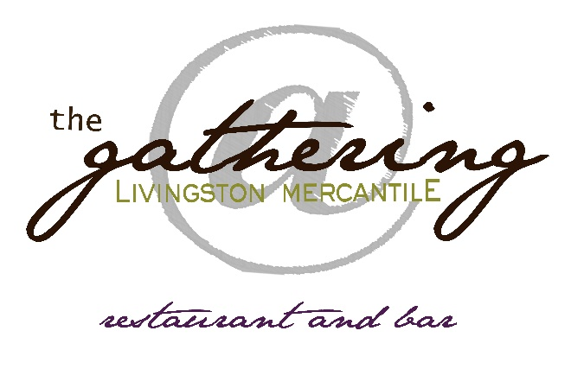
CATERING MENU
Mariah Arinder
Mariaharinder1@outlook.com
601-260-1765
Please call or text to order.
Include name, number of guests, catering options
and date of order in message. Any messages left after 5pm will be addressed the following day!

106 Livingston Church Road
Flora, Mississippi 39071
www.livingstonmercantile.com

our lunch at your place
Delivery style (15 person minimum) with 20% gratuity

Sides
Also available in Large servings
Large pan $60 /Small pan $30

Mashed potatoes
Smashed sweet potatoes
Braised greens
Coleslaw
Mac and cheese
Braised green beans
Southern style peas

SANDWICH LUNCH TRAY
Small 79.99 Large 149.99
TURKEY & PROVOLONE
lettuce and tomato
HAM & AMARICAN
lettuce and tomato
CLUB
ham, turkey, bacon, American, lettuce & tomato

Call and ask about any modifications, requests, or allergy needs!

WE DELIVER ACROSS MADISON, YAZOO, & WARREN COUNTY

DELIVERY FEES ARE NOT INCLUDED IN GRATUITY.
0-20 MILES $20
20-40 MILES $40
40-60 MILES $60
(Contingent on driver availability.)

